**Introduction**\* **Classes**, **Objects**, **Constructors**, and also first of 4 major components of Object Oriented Programming, which is **Inheritance**.

**Classes Part 1**  
* Real world Objects have 2 major characteristics:  
1) **State**  
2) **Behavior**  
* State in case of a computer might be the amount of RAM it has, the operating system it’s running, the hard drive size, the size of the monitor.  
* State in case of an ant might be the age, the number of legs, the conscious state whether the ant is sleeping or awake.  
* Behavior in case of a computer might be booting up, shutting down, beeping or outputting some form of sound, printing something, drawing something on the screen.  
* Behavior in case of an ant might be eating, drinking, fighting, carrying food.  
* Now software objects are very similar to real world objects because they also consist of state and behavior.  
* Software objects store their **STATE** in **FIELDS=VARIABLES**, and we know fields as Variables and they expose their **BEHAVIOR** with **METHODS**.   
* **Think of a CLASS as a template or a blueprint for creating Objects**.  
* `public class Main {}` is actually a statement which creates a new class in Java.  
* Basic primitive types are fairly limitting, so a class could be thought of as a powerful user-defined data-type, sort of an extra data-type, that’s not really correct in the true meaning, but it gives you an idea of what classes are, they really enable you to have a pretty powerful user-defined type, where you can create something way more powerful than a regular primitive type.  
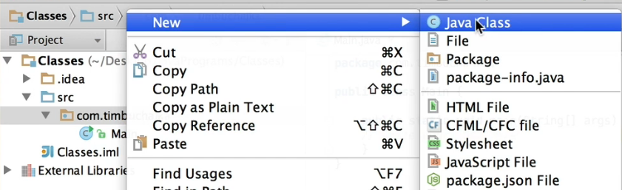  
* Every time you create a new class, it’s creating that class in a particular folder.  
* **PUBLIC** keyword is an access modifier that we use here to determine what access we want to allow others to have to this new class. So the word `public` means **unrestricted access to the class**. Now usually, at least initially, you’re gonna be using public for pretty much all your classes but other access modifiers we could use include **PRIVATE** and that’s where **no other class can access that class**, **PROTECTED** which **allows classes in this package to access your class**, and you can also remove the access modifier completely if you prefer, but we’ll be talking about it more in the future.  
* You’ve seen **variables used inside a method** => **LOCAL VARIABLES** because they are local to or actually belong to that method and **you can’t access those local variables outside of that method**. You saw that also with the code blocks that we created in past videos - once you access that, you can’t access those variables outside of that block.  
* Classes allow us to create variables that can be seen and are accessible from anywhere within the class that we’re creating. These are knows as **CLASS/MEMBER VARIABLES** **but most commoly refer to them as** **FIELDS**.  
* When you’re creating a field for a class, you need to also specify an access modifier that works the same way as the access modifier for a class definition does.  
* As a general rule, when you’re defining fields in Java in a class, you go with the access modifier PRIVATE, unlike the class where we’ve gone with PUBLIC.   
* **What PRIVATE means when talking about FIELDS is that we’re adhering to ENCAPSULATION which is a key fundamental rule of OOP**.  
* **ENCAPSULATION** in Java is used to **hide the FIELDS and METHODS from public access**. So it really means that the internal representation of an object is gonna be hidden from view outside the object’s definition. So in other words, the internal workings of a particular object (an object is going to be created from our templates from our class) can only be accessed by this class or by this object. We’re not allowing outside access to that.  
  
* So what we’re trying to create here is a template of the variables that would be part and parcel of a Car. Obviously, if we’re creatin a real application, there’d be a lot more fields, there could literally be hundreds of different fields that we could add for a Car, we’re just keeping it simplistic to start with. Those variables are the **STATE which we’re defining as FIELDS**.  
  
* We created an object from that class blueprint.   
* When you’re creating a new object from a class, you need to initialize it.  
* We’ve created an object called porsche based on the Car class/template.  
* **If you type porsche. then you see a list of methods that are accessible from the class, from this object**.  
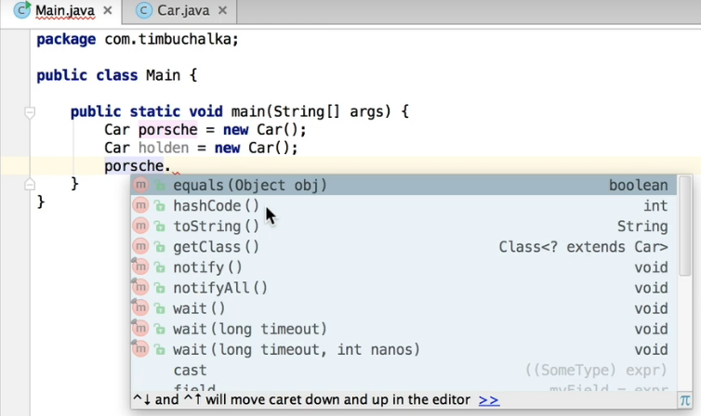  
* These are added automatically by Java whenever we create a new object.  
* So you could say that they’re inherited from the Java functionality. To be correct, the Car class has **inherited** these from a **BASE Java CLASS**.  
* To access the STATE = FIELDS --- right now we don’t seem them in there as an option because we defined them a PRIVATE which means don’t allow a class outside of the Car class to access these variables/fields. If you want those to be accessible outside of the Car Java class, you need to change the access midifier to PUBLIC.  
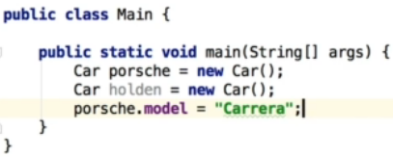 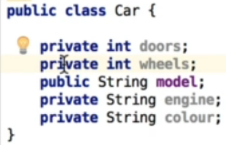  
* We’ve defined the model for our porsche object. That’s one way of accessing the data but it’s not actually a good one because it really more or less violates the rules of encapsulation, so what we should be doing is making sure that that functionality is restricted and placed in the Car Java class.  
* Let’s change it to PRIVATE again and create a method.  
* When you create a method in a class, that method is then attached to all the objects that you create for that particular class. Now in the past, the only methods that we’ve created were **STATIC** **METHODS** and **STATIC** **CLASSES** aren’t really the same thing but we’ll be talking more about those later. For now let’s create a **PUBLIC METHOD**.

**Classes Part 2**  
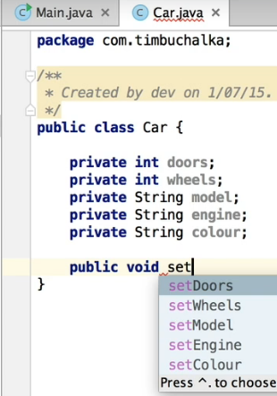  
* Now do we distinguish between these two `model` variables?  
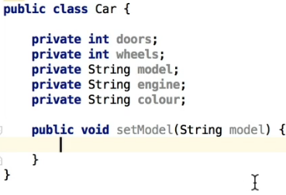  
* You type `**this**` when referring to the FIELD of the CLASS.  
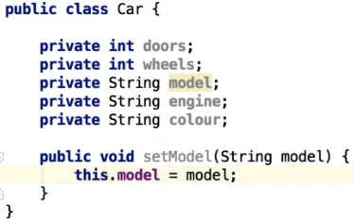  
* So that’s a way of updating the model using a method instead of trying to access it directly.  
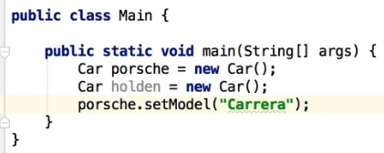  
* Unlike data-types, classes don’t have default values so you need to initialize them using the new keyword, you can’t just type `Car porsche;` and then use its method.  
* The method we created is what’s called a **SETTER**.  
* Now let’s create a **GETTER**.  
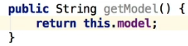  
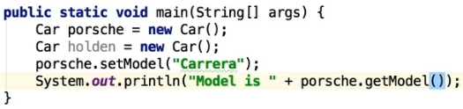  
* If we tried to print it out before assigning Carrera to it, it would give us NULL.  
* **NULL is the internal default state for a class and also for a string**. String is actually a special class.  
* What’s the advantage of SETTERS/GETTERS? By using the .setModel what we could do is, for example, we could go back to our Car.java to our .setModel method and do some validation.  
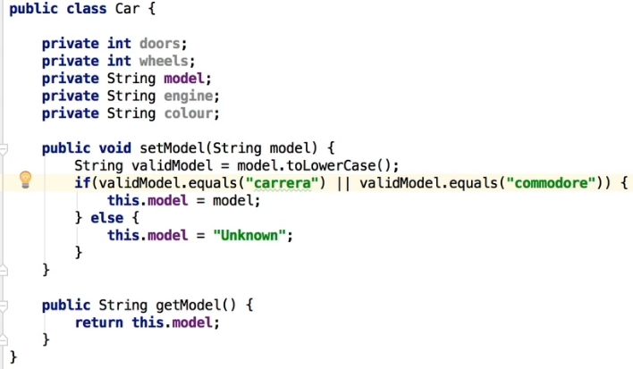  
* string**.equals(“something”)** is a way to test that a particular value of String is equal to another type.  
* So you can see how it’s very useful to have this type of functionality, the validation. Not doing it in the main but doing it within the Car class itself via the methods that we’re setting up in our class. So it means when you’re creating a class, you can set up all the rules related to that class, what is valid, what is not valid, and have it all set up, all that functionality set up within that class itself, so that is inherited when we create the object. What that means is that the code that is creating objects, can’t make invalid objects so to speak. It can’t create something we haven’t defined as being valid in our class.  
* That’s really the whole concept of **ENCAPSULATION** - that we’re not allowing people to access the FIELD directly by forcing them in this case to assign the model using a method, we can really make sure that the data within our objects are more valid and have been validated and are correct.

**Coding Exercise 29: Sum Calculator**  
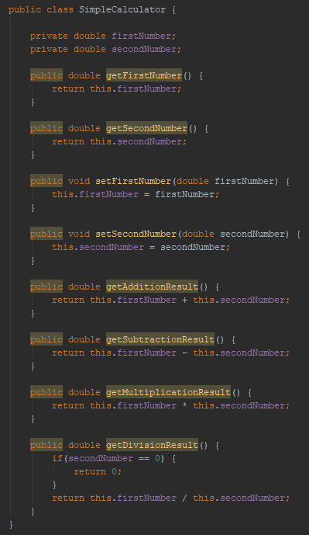  
**Coding Exercise 30: Person**  
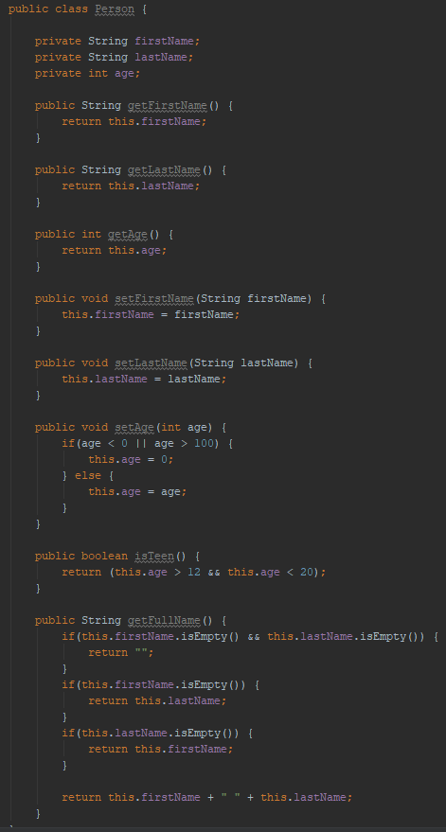

**Constructors Part 1 (+ Challenge Exercise)**  
* **A trick in IntelliJ to quickly create GETTERS/SETTERS because it’s just a common thing that you do regularly, there’s a way to automate that**.  
* **Code => Generate… => Getter/Setter/Getter and Setter => select which fields you want**.  
* When we create a new object, we can then use all the setters to set the values to something but if we had a lot of fields, it could be quite a bit of code to actually do that.  
=> There is another way of doing this when you’re create an object for the first time using a class and that’s using **CONSTRUCTORS**.  
* With a constructor you can essentially do all these commands to set the initial parameters or the initial values of the fields and any other initialization you wanna perform in the one hit using a constructor.

* **A constructor is actually created for you automatically by Java and when you actually type `new` and the name of the class in brackets, it’s actually calling the constructor**.  
* So it’s actually calling that special method that creates the class. So it’s purpose is to physically create the object from the class for us.  
* **public ClassName() {}**  
* So that’s what the purpose of the constructor is - to essentially initialize the object that you’re creating and do whatever else you wanna do at the time the object is being created. So it’s only ever called once at the start when we’re creating the object.  
* **Just like methods, constructors can be overloaded**.  
*   
  
* Besides overloading the constructor, we can call one constructor from another constructor. That sounds a little bit confusing but the idea of that would be, if an empty constructor is called, perhaps we want to create the object with some default values.  
* **this()** **calling another constructor within a constructor**.  
* One other thing to keep in mind when using this() to call another constructor is: what you need to do is **make sure that’s the first statement that’s executed**. So we couldn’t paste in the System.out.println() as the first line in the constructor because it’s gonna actually come up and say: “call to this() must be the first statement in constructor body”.  
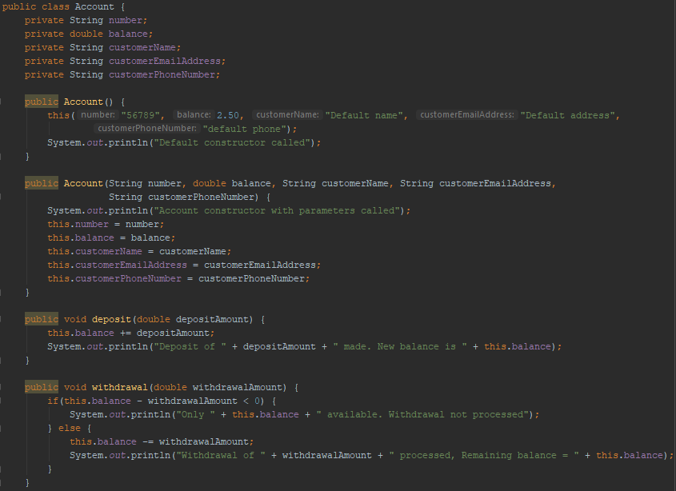  
* Not screenshotting the regular getters/setters as those look the same.

**Constructors Part 2 (+ Challenge Exercise)**  
* We updated the fields directly in the constructor but we can use the setters to do that. This would be especially handy if we had some kind of validation in the setters.  
* In Java there are conflicting opinions as to which is the best approach because you’ll find out in the next video when we start talking about sub-classing, in other words talking about Inheritance, that this won’t always work. **So the general rule of thumb is that it’s actually better to save the values from the constructor directly to the field rather than calling the setter because there can be scenarios where this code that’s in the setter isn’t executed**.  
* **So in general don’t call any other methods besides other constructors in the constructor**.  
* And the other reason for that is that this is the point in the constructor where the object is being created, so consequently some aspects of the initialization may not have been finished while you’re in the constructor.  
* **IntelliJ quick way of creating a constructor**:  
* **Code => Generate… => Constructor => which fields you wanna include**.  
* We can then change to code to something like this to make sure all fields are initialized with values:  
  
* You will find as you start creating and writing more complex code that it’s not unusual to see multiple constructors like this. And in that situation, **often you do all your initialization in the one constructor like you see in our code (the one with all fields), and the other consturctors should just call that major constructor**. That’s a good way of doing things and it often leads to really good coding because you’re not having to duplicate code or duplicate initialization in more than one place.  
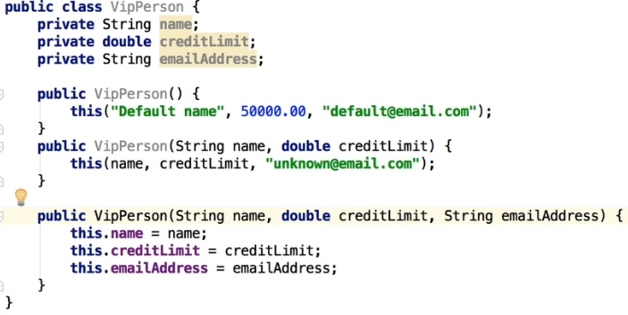  
* The first 2 constructors call the 3rd constructor and the 3rd constructor is the only one that actually does save values into our fields.  
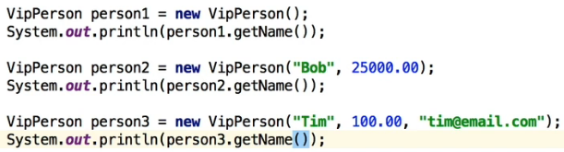  
=> prints: “Default name”, “Bob”, “Tim”.

**Coding Exercise 31: Wall Area**  
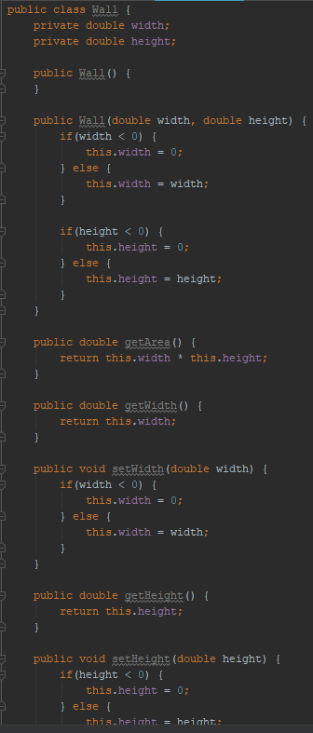

**Coding Exercise 32: Point**  
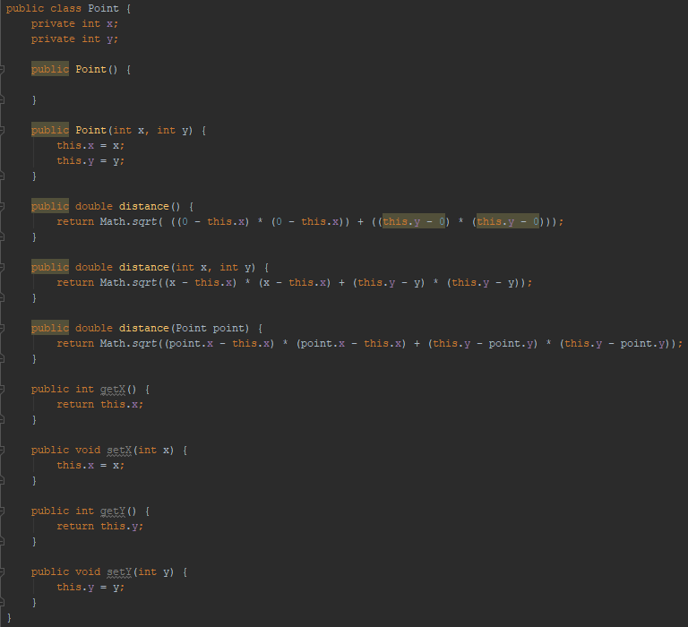

**Coding Exercise 33: Carpet Cost Calculator**  
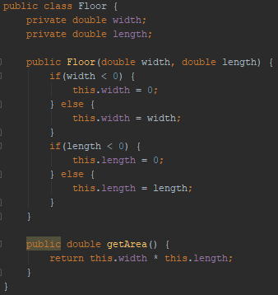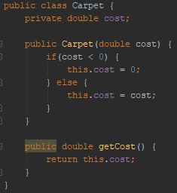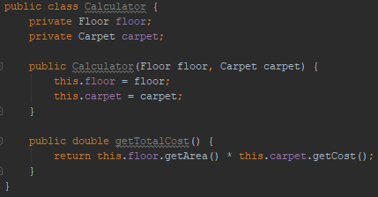  
**Coding Exercise 34: Complex Operations**  
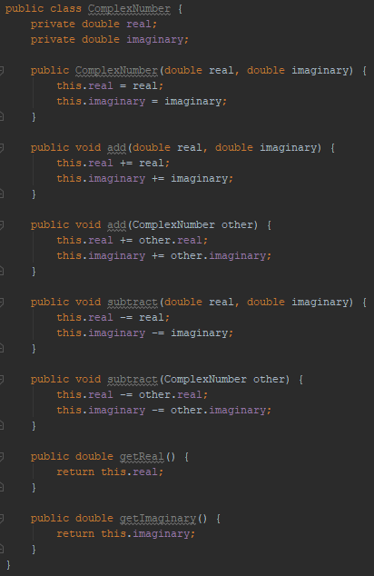

**Inheritance Part 1**  
* Different kinds of objects have a certain amount in common with each other.  
* Using an example of computers you could say that an iMac computer, an Android Nexus 9 tablet, and a Dell PC all share the characteristics of computers. They’ve got RAM (Random Access Memory), ROM (Ready-Only Memory) and they’ve got a current state as to whether the device is on/off, and so on.  
* So they share common characteristics, but yet each of these devices add additional features that collectively make them different to each other.  
* For example, iMac runs the OS X operating system, it’s got an Intel CPU, got a hard drive, USB ports.  
* An Android Nexus 9 tablet runs on the Android operating system and it’s got a touch screen for input.  
* A Dell PC Runs Windwos, it’s also got an Intel but maybe an AMD CPU, it’s got a hard drive, a mouse, and so on.  
* So what OOP really allows us to do is to create classes to inherit commonly used state and behavior from other classes.  
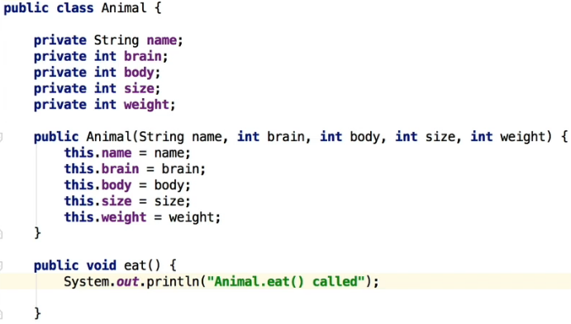  
* We don’t care about the values right now, as you can see I just used int for brain/body as well.  
* Now let’s create a new class and inherit from this base class.  
* `**extends**` keyword to inherit from a class.  
* **We need to make sure that we have a constructor for the Dog class that calls the constructor for that other class**.  
* If you create a constructor in Dog using IntelliJ it actually gives you what you need:  
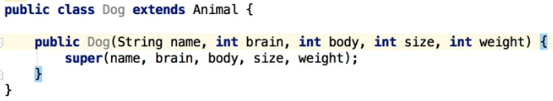  
* `**super**` keyword calls the constructor that is for the class that we’re extending from.  
* What we can also do at this point is assign extra state - fields and extra behavior - methods that are unique for the Dog and not necessarily applicable for every animal.  
* That is what Java and other OOP languages allow you to do - to create a base class that’s got the basic information to work on, and then you can extend=inherit from that class, which indeed is very powerful because what that also means is not only with the fields, we can also add specific methods.  
* **In this constructor we also need to initialize the Dog specific fields besides the inherited ones**.  
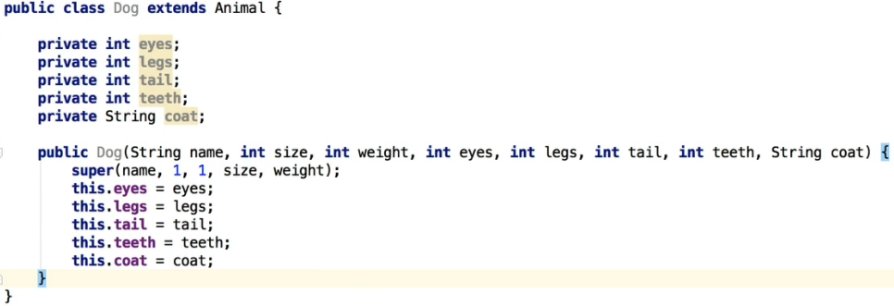  
* We use 1 for the brain and body to indicate they have it and the user doesn’t have to specify that.  
* **We can also override the base class’ methods**.

* Even though it doesn’t say it with the extends keyword, every class inherits from this Object:  
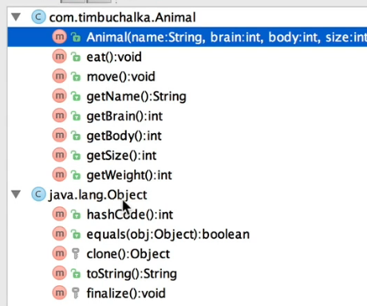  
* It’s a special class created by Java.  
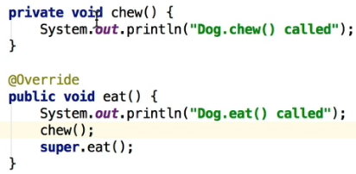  
* What super() means here is call the super() equivalent of that class, using a method from the **superclass**.  
* **This will first call the Dog.eat(), then Dog.chew() and then Animal.eat()**.  
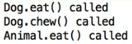  
* That’s overriding a method in a super class.

**Inheritance Part 2**  
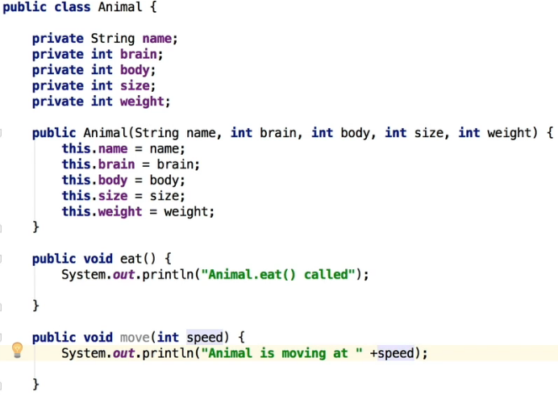  
* **You can call it by typing `move()` or `super.move()` but generally speaking it’s better tu use move() because that then means if you override the move() function at a later time for Dog, it’s gonna correctly call that move() method**.

* **Dog**  
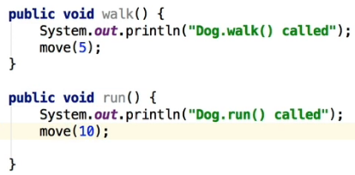  
* If we override the move() in Dog, then super.move() would call the old one from Animal while move() would correctly call the new overridden one.  
* **Dog**  
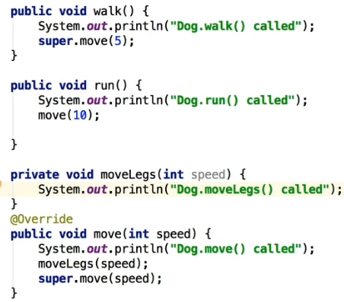 **\* Fish**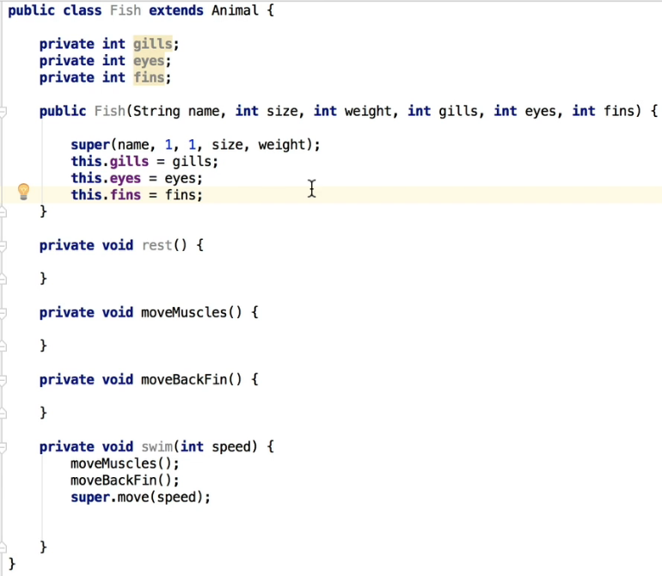

**Reference vs Object vs Instance vs Class**  
* Let’s use the analogy of building a house to understand Classes.  
* A **CLASS** is basically a blueprint for a house, using the blueprint (plans) we can build as many houses as we like based on those plans.  
* Each house you build (in other words instantiate using the new operator) is an **OBJECT** also known as an **INSTANCE**.  
* Each house you build has an address (a physical location). In other words if you want to tell someone where you live, you give them your address (perhaps written on a piece of paper). This is known as a **REFERENCE**.  
* You can copy that reference as may times as you like but there is still just one house. In other words we are coyping the paper that has address on it not the house itself.  
* We can pass references as parameters to constructors and methods.  
* Let’s go a little deeper to make this clearer.  
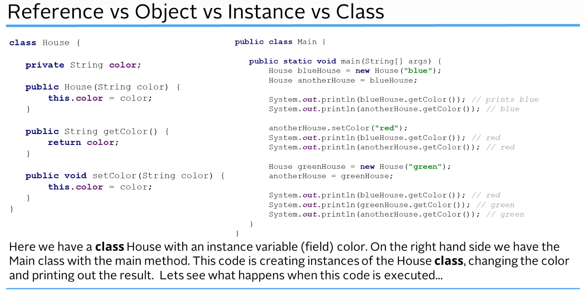  
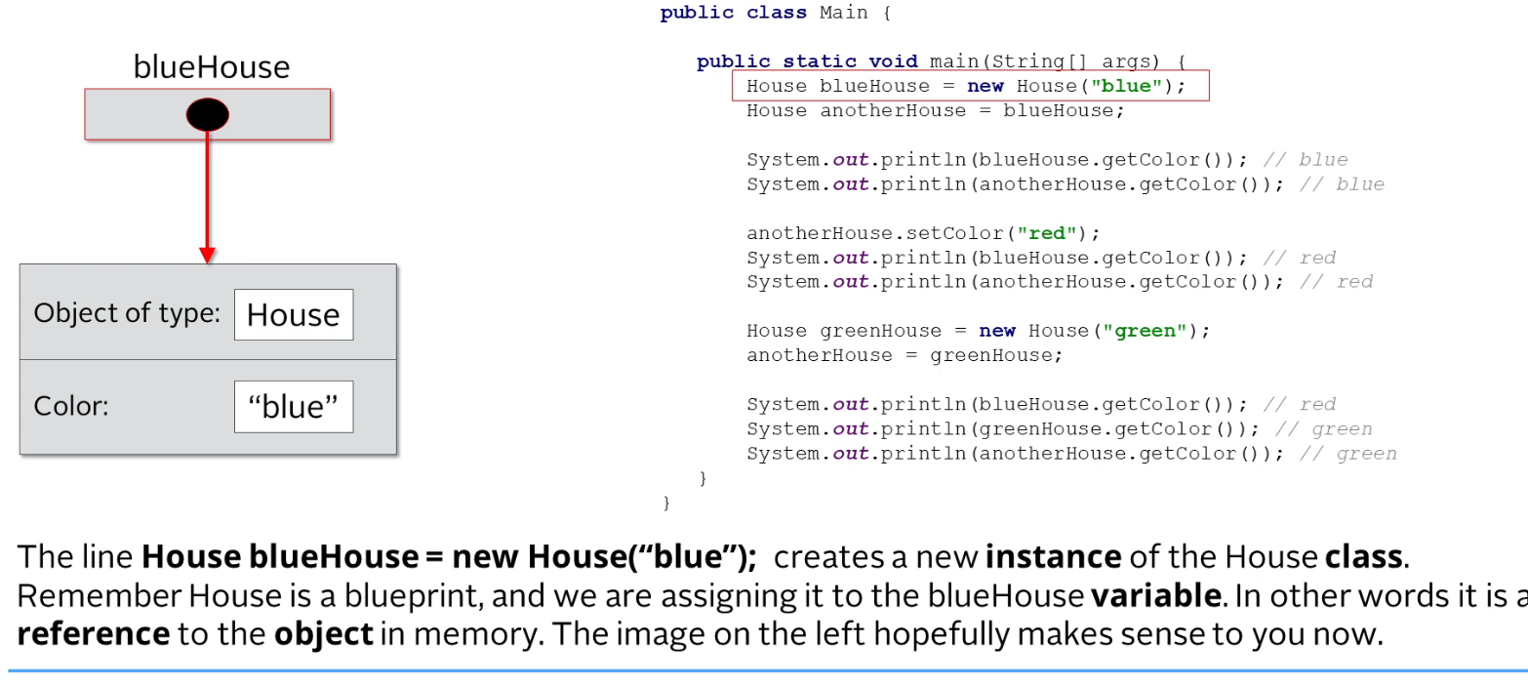

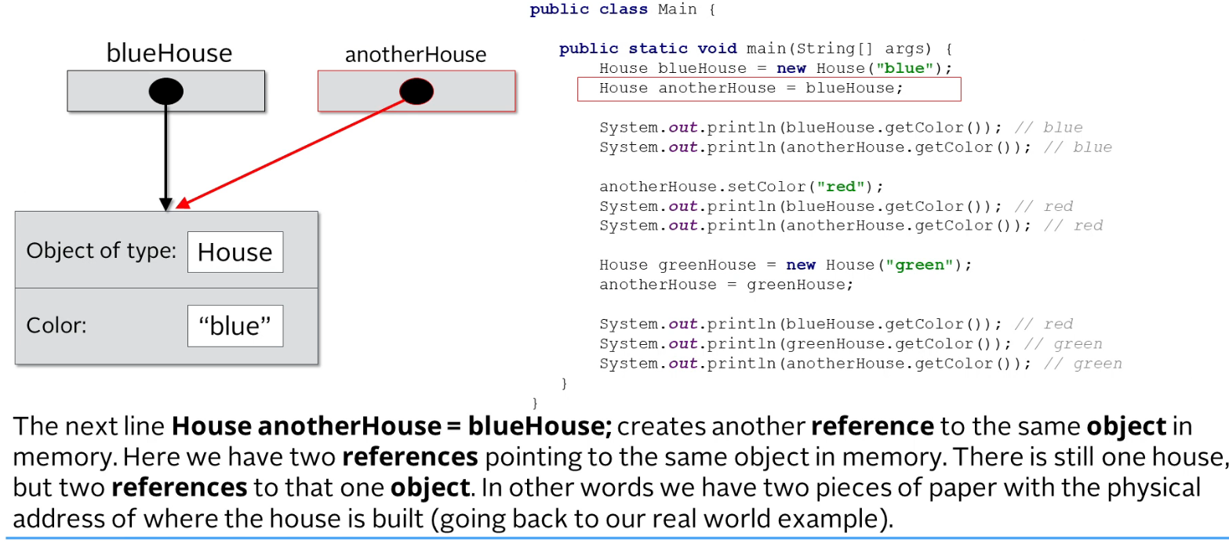  
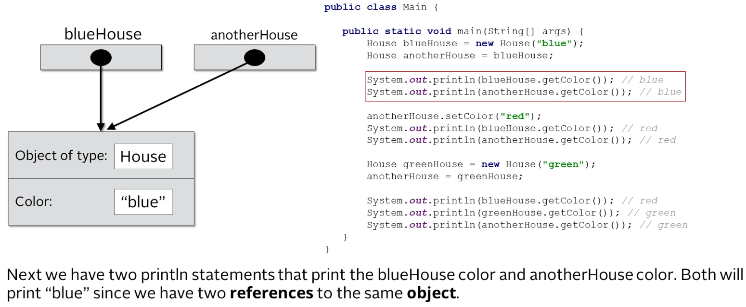  
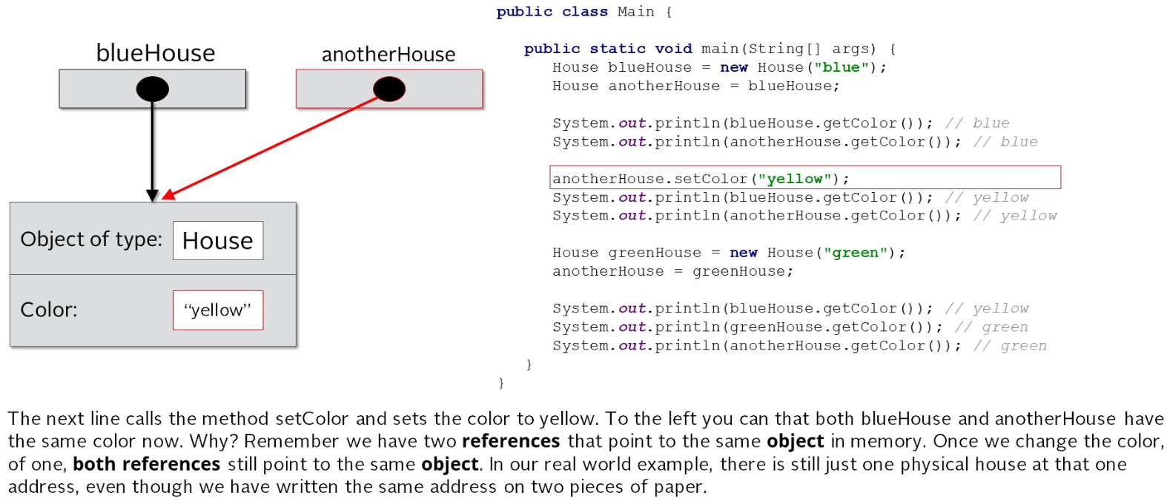

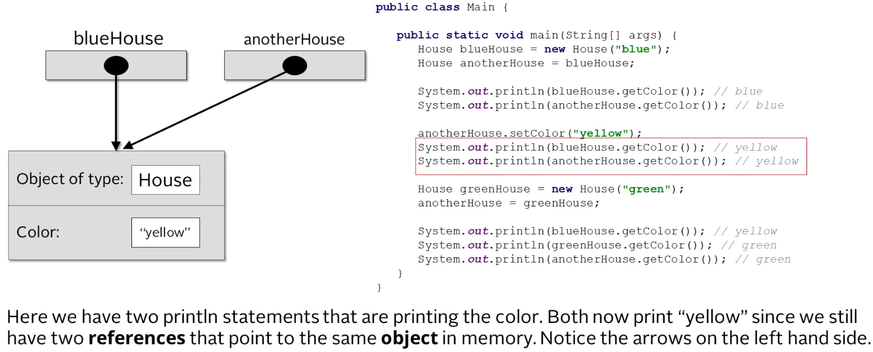  
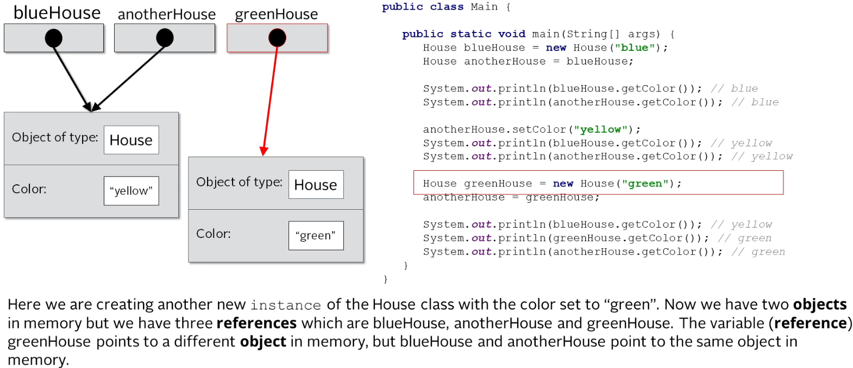  
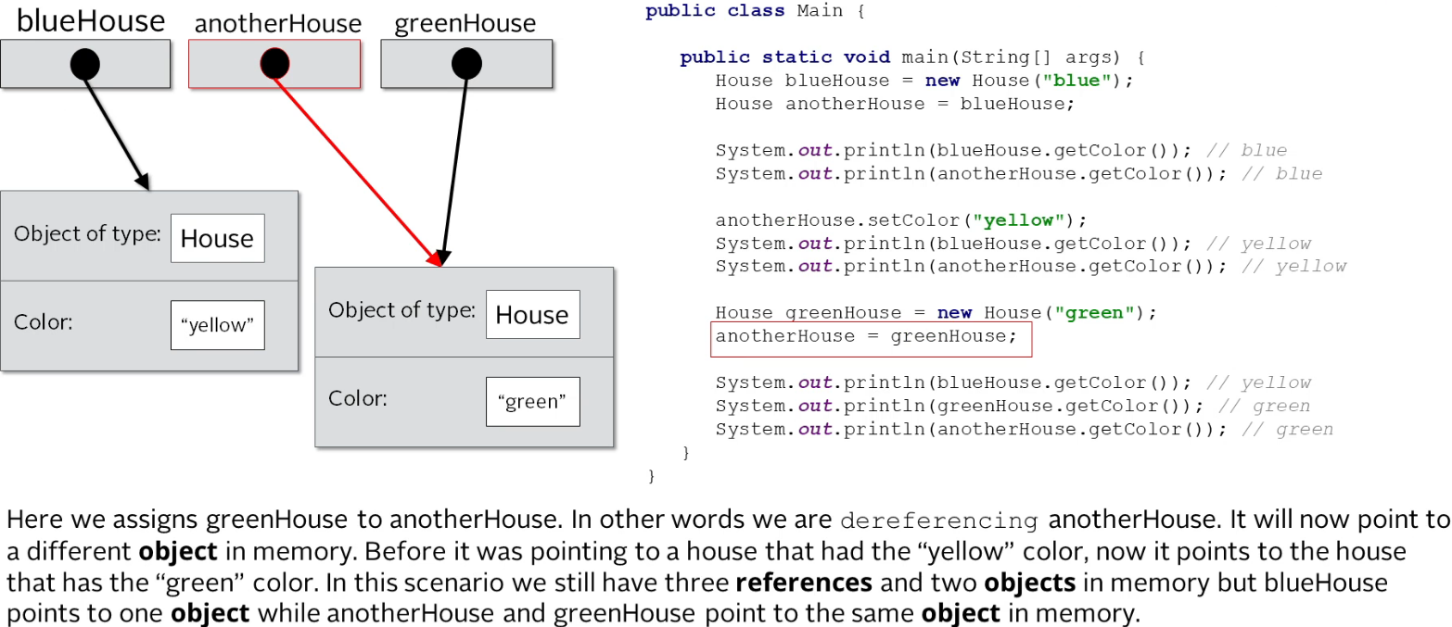

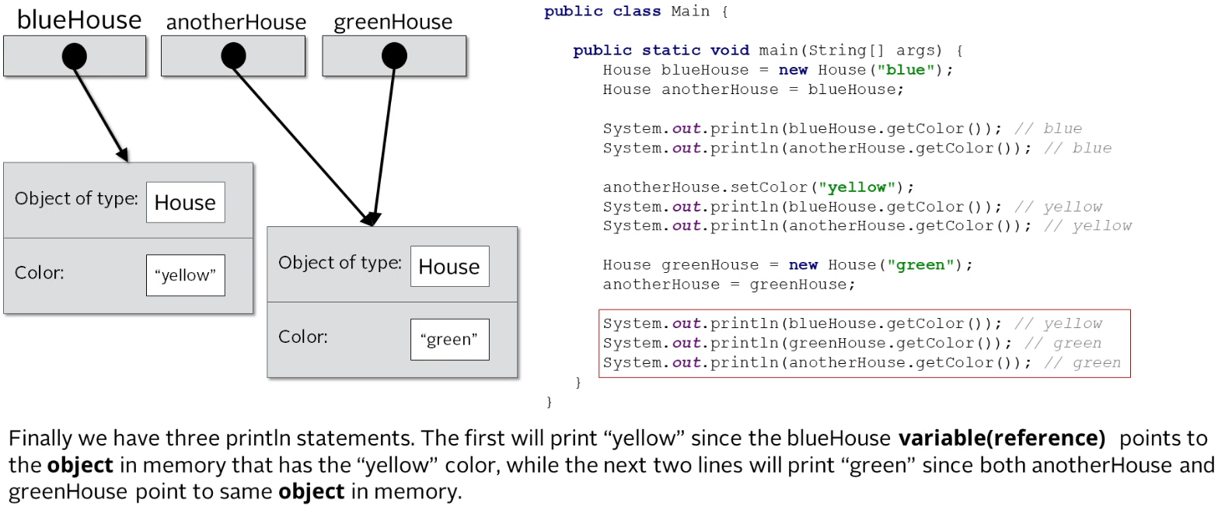  


**this vs super**  
* **this()** vs **super()** method calls.  
* **this** and **super** keywords will be discussed first.  
* `super` keyword is used to access/call the parent class members (variables and methods).  
* `this` keyword is used to call the current class members (variables and methods). This is required when we have a parameter with the same name as an instance variable (field).  
* NOTE: **we can use both of them anywhere in a class except STATIC areas (the static block or a static method). Any attempt to do so will lead to compile-time errors (more on static later)**.  
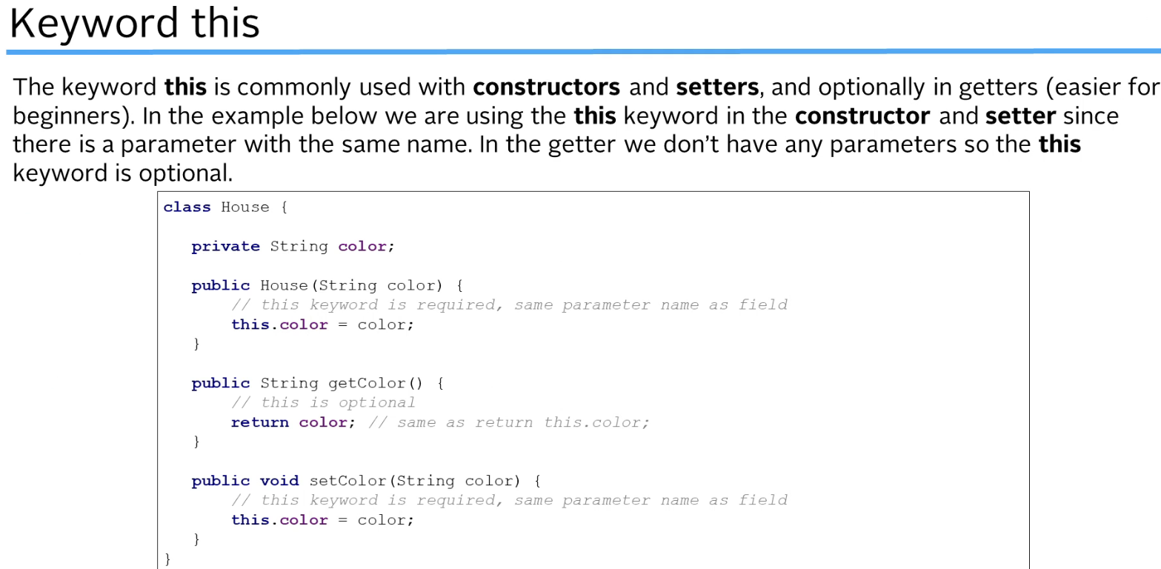

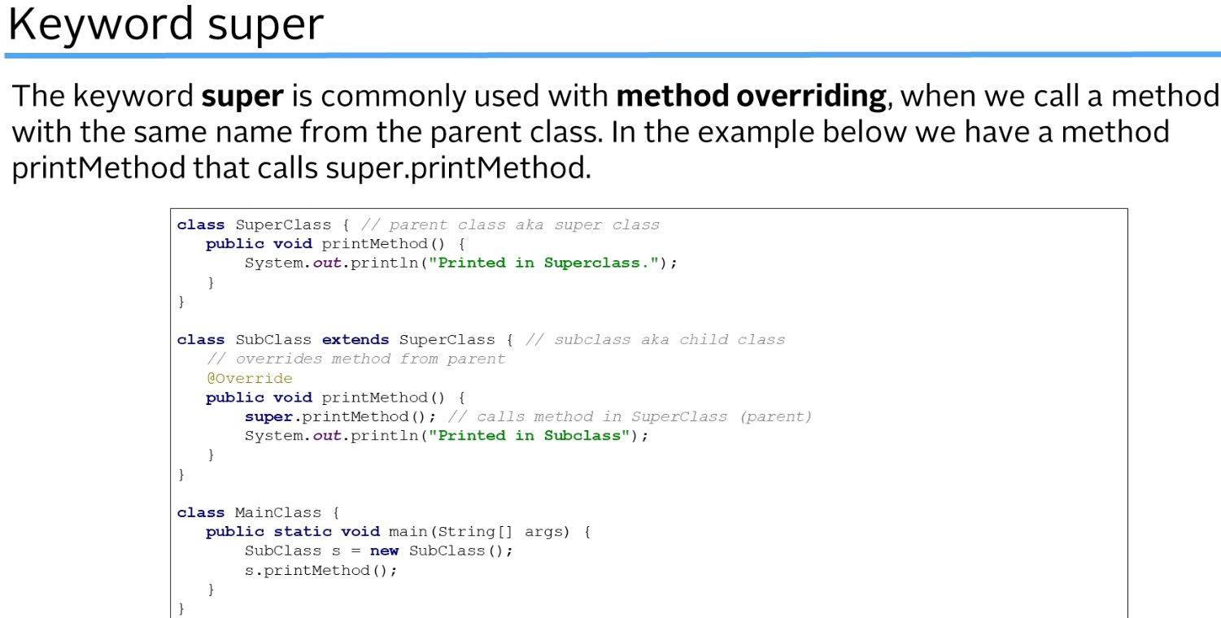  
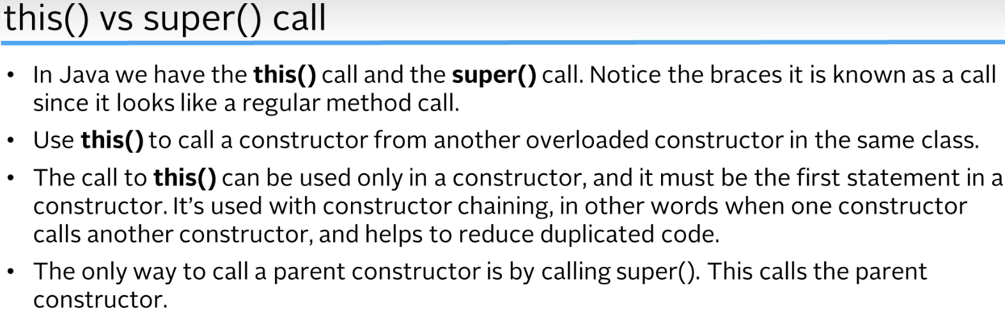  
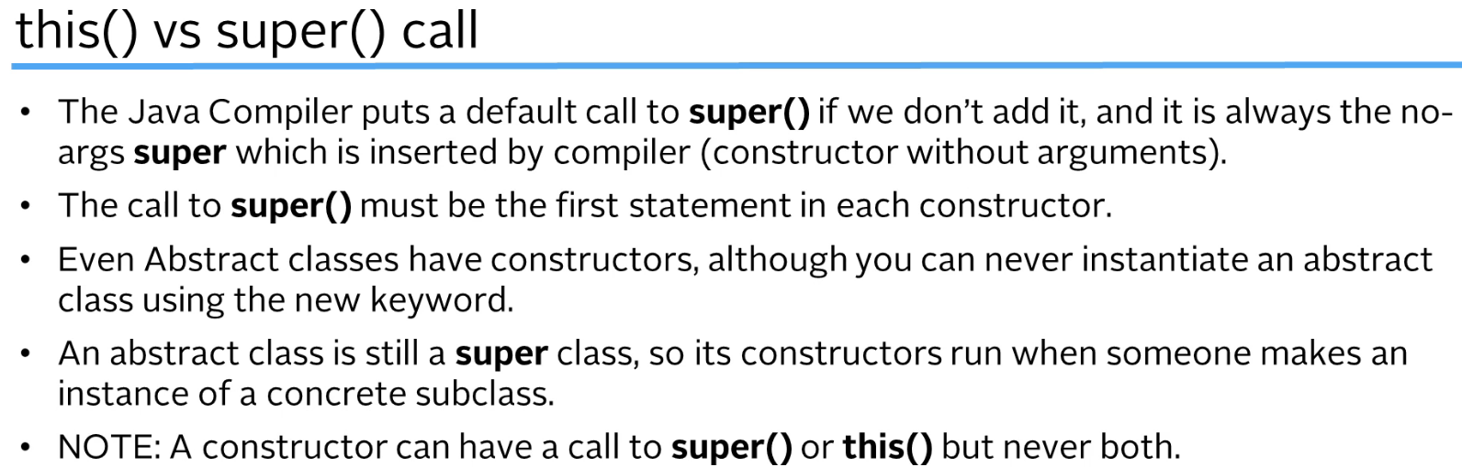  
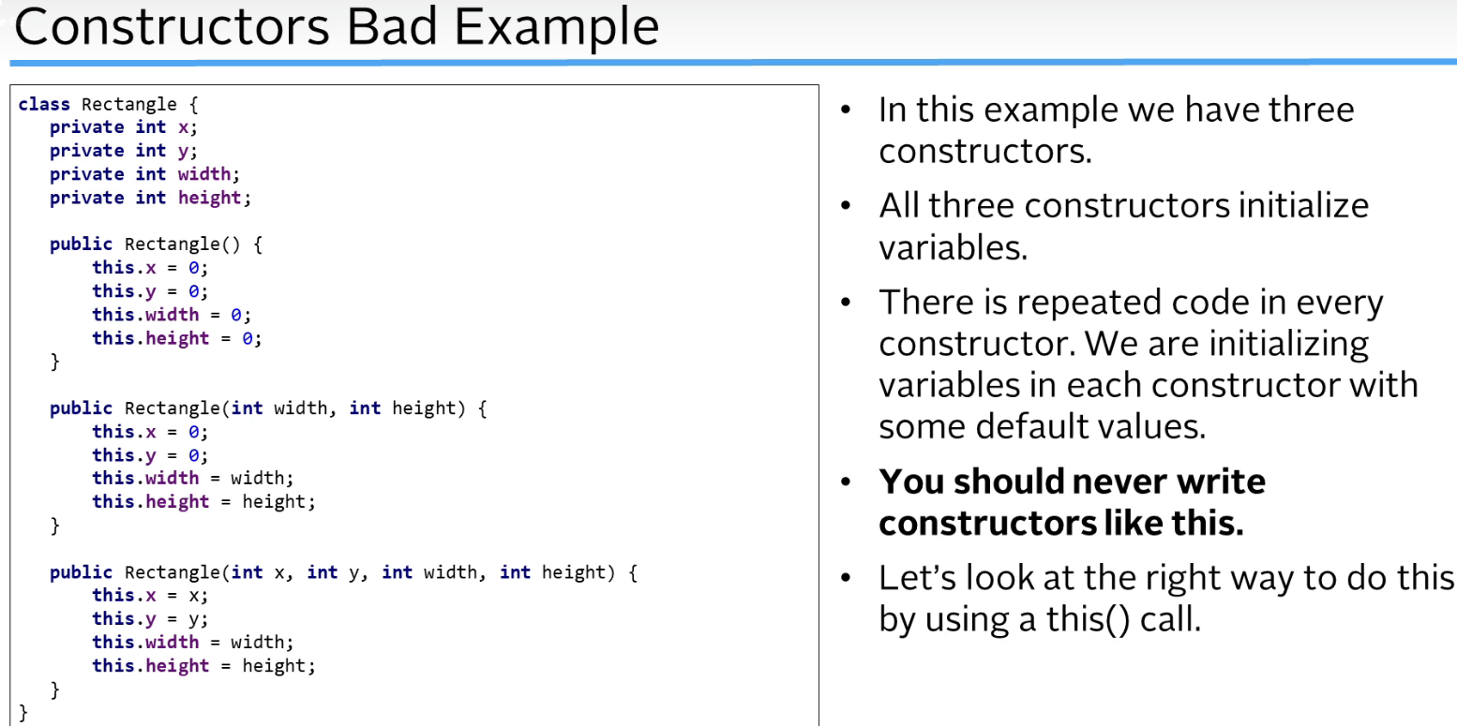  
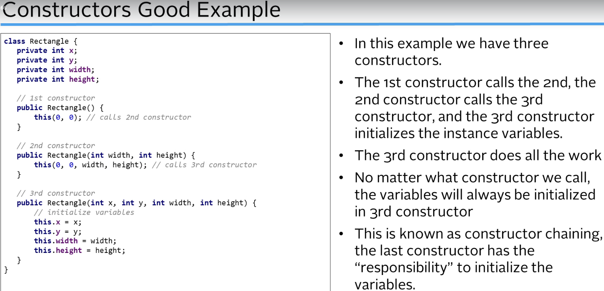  
* **Constructor** **Chaining** **= giving the last constructor the responsibility to initialize the variables, to do the actual initialization of the instance variables**.  
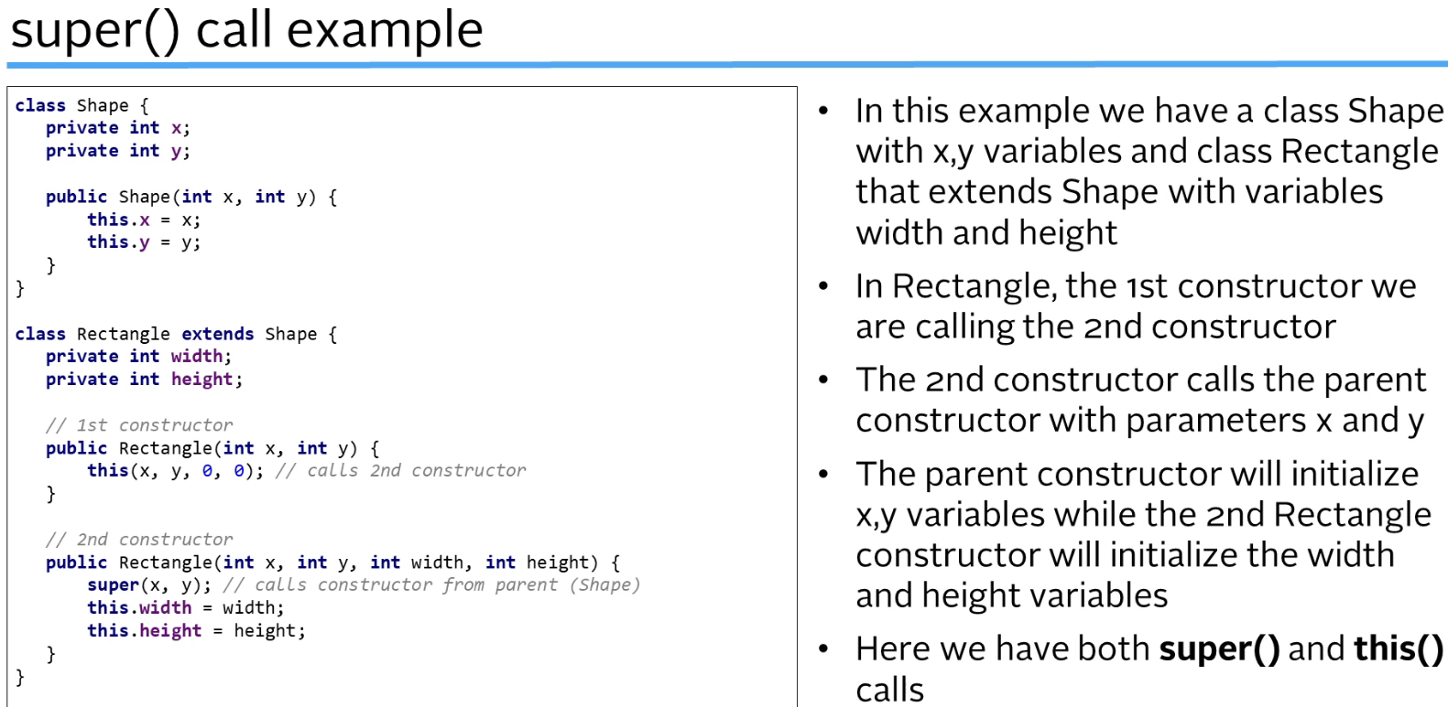

**Method Overloading vs Overriding Recap**  
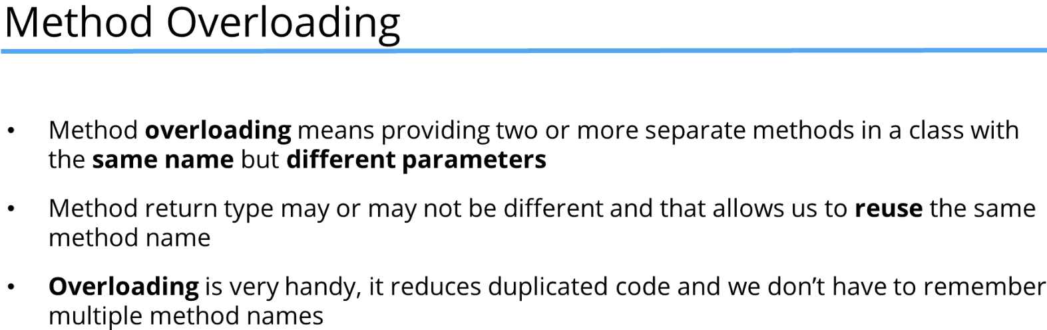  
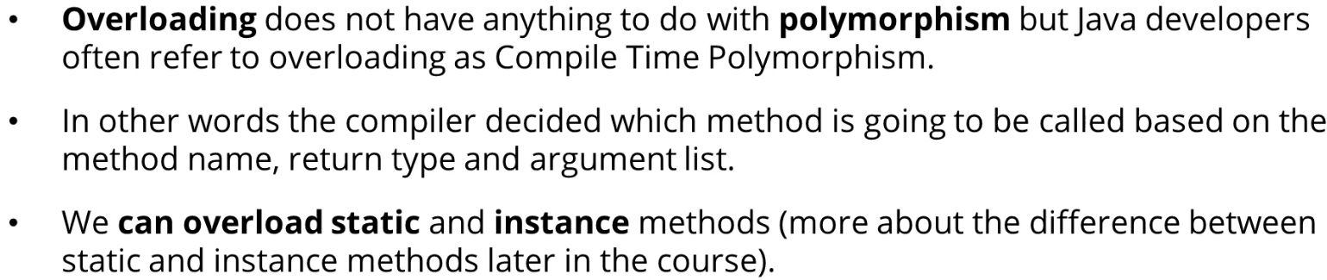  
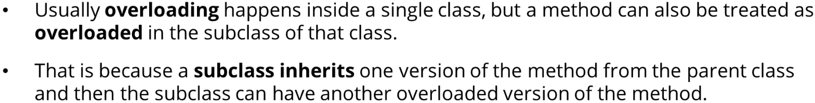  
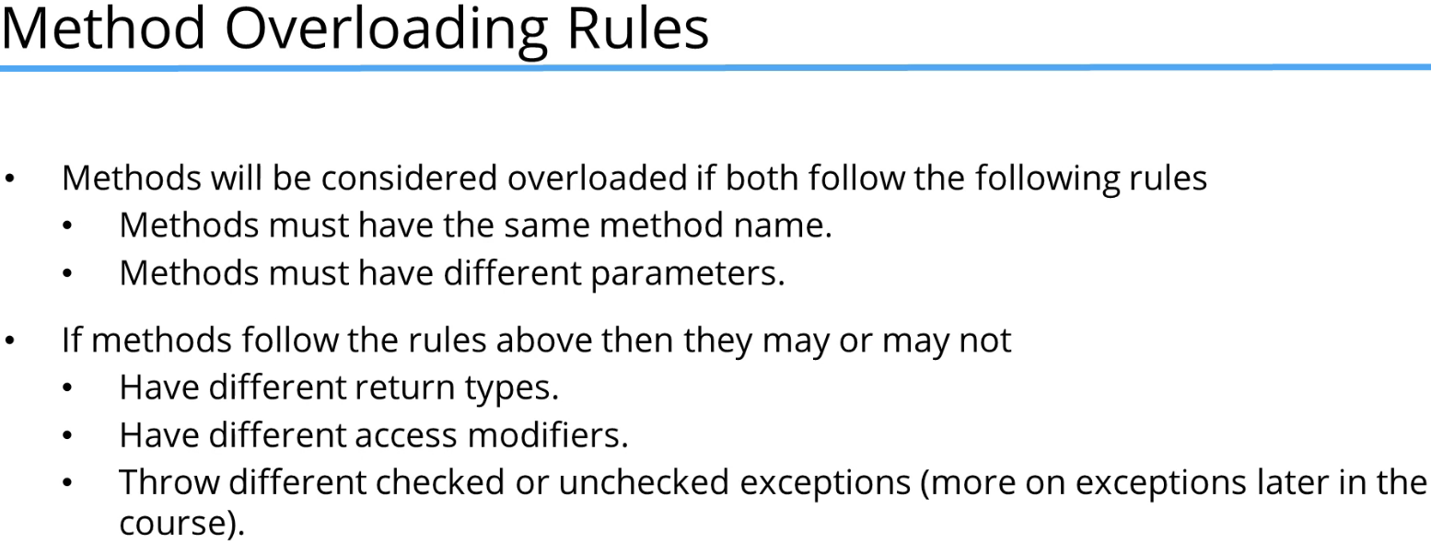

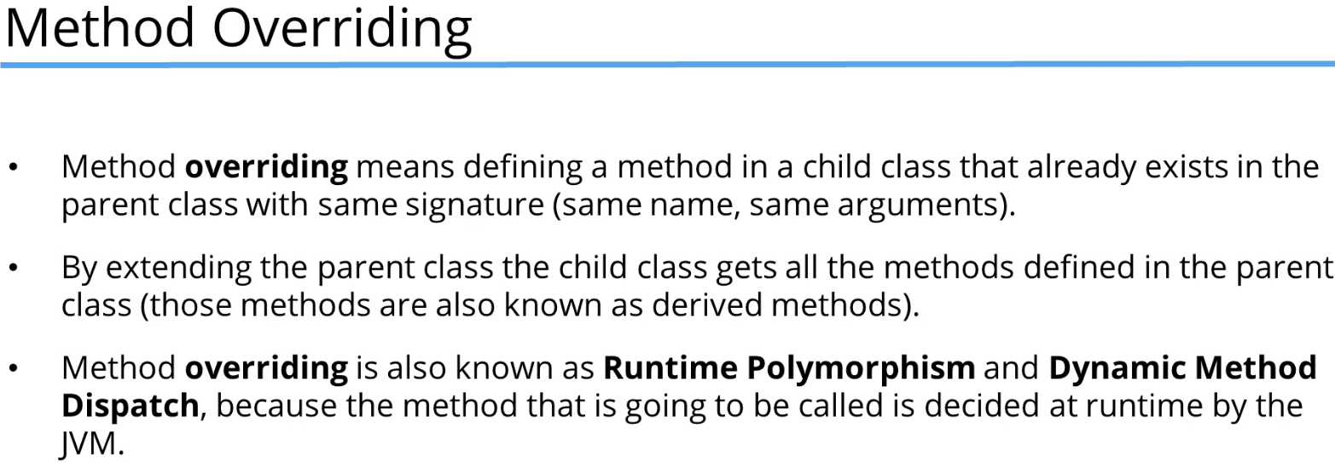  
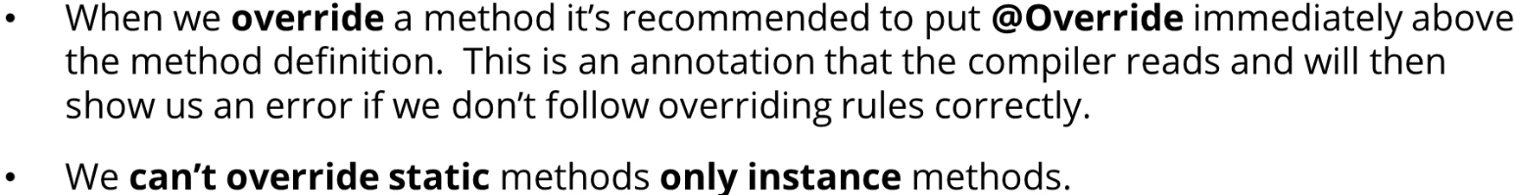  
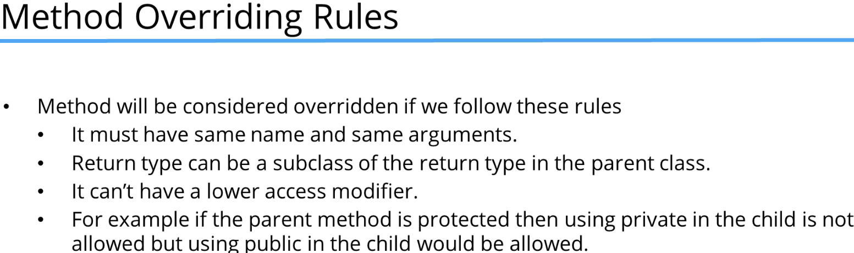

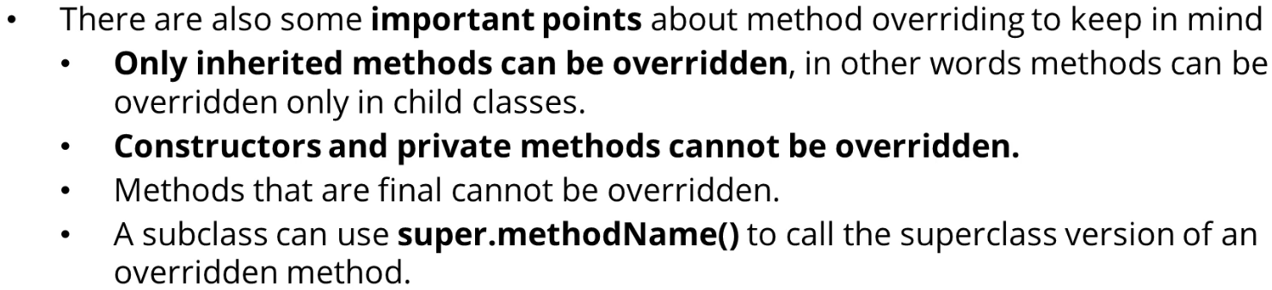

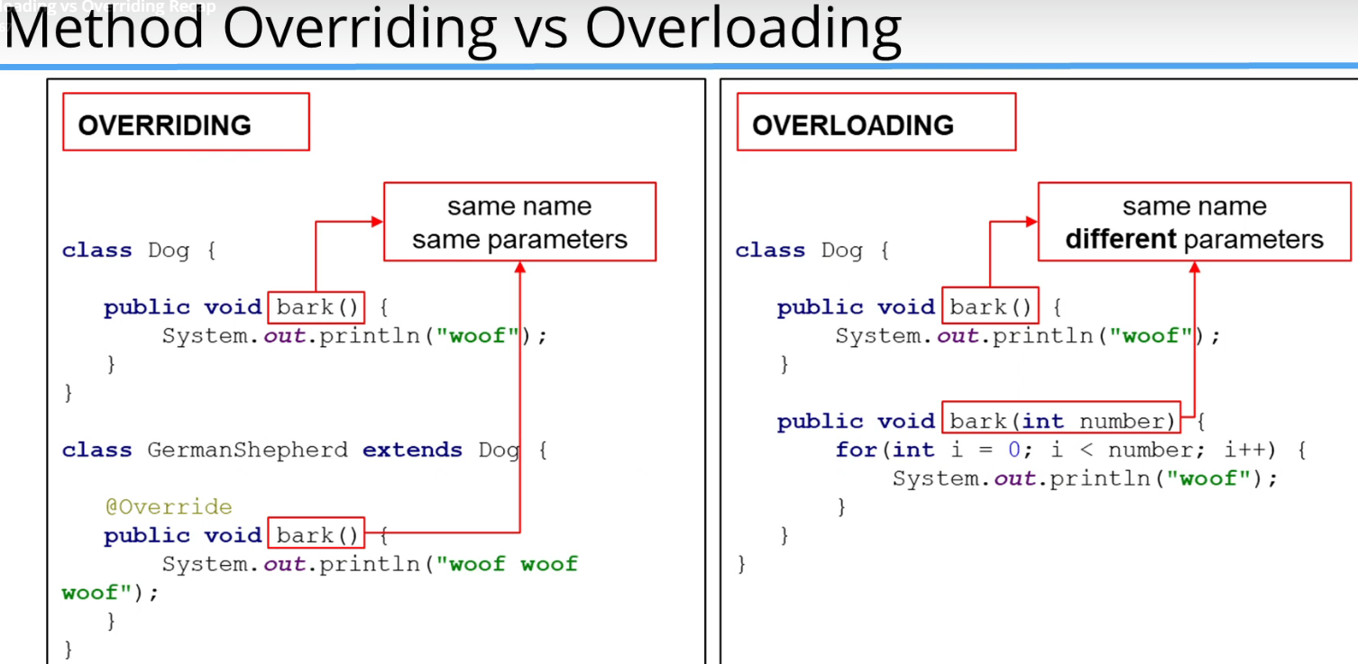

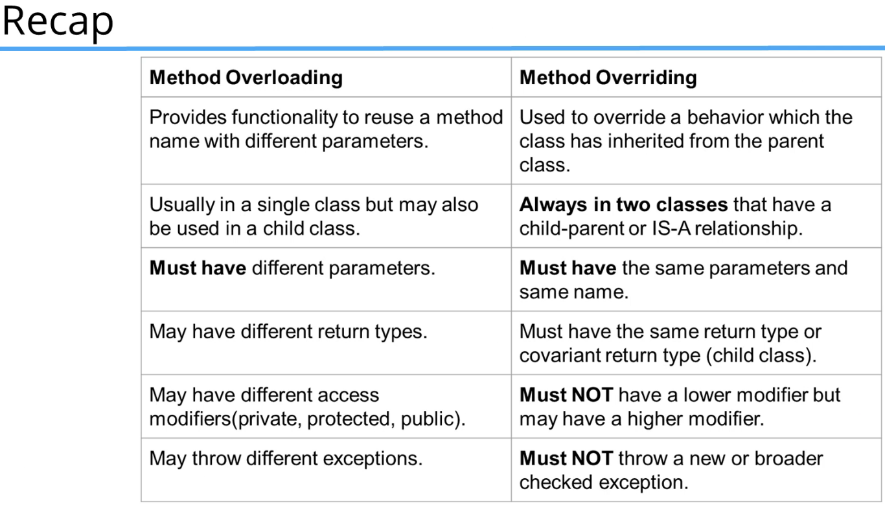  
* **Covariant return type is just a return type that is in the parent-child relationship = has a is-a relationship**.  
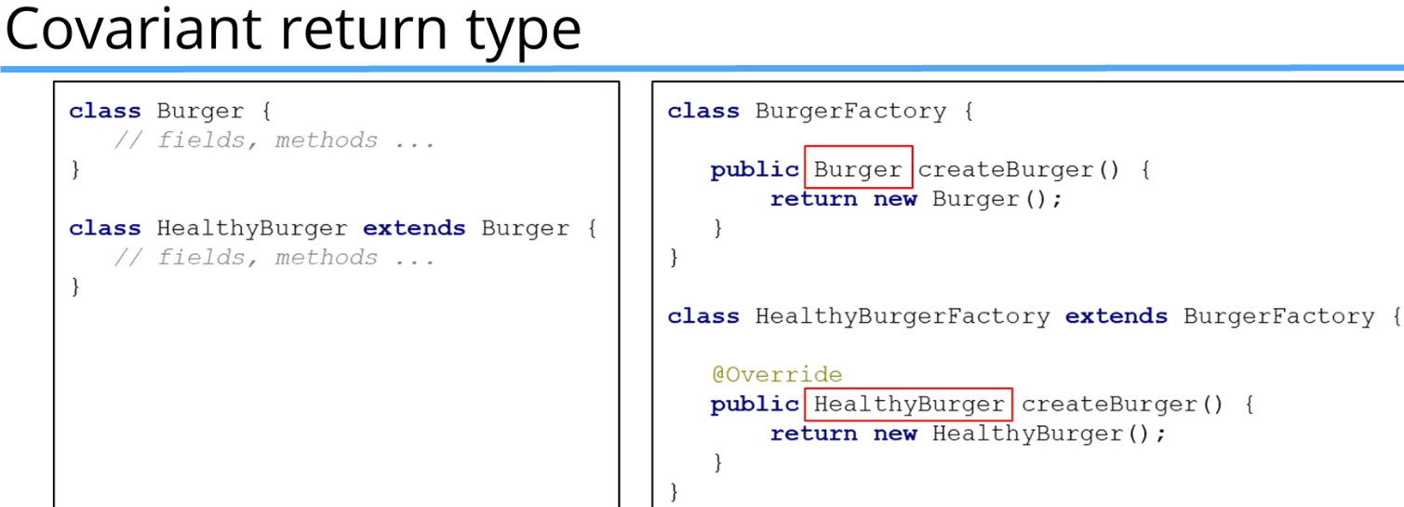  
* **For overriding if the parent method is PROTECTED, then the child method can’t be PRIVATE but it could have a higher modifier so PUBLIC**.  
* **So the method createBurger() in the class HealthyBurgerFactory can return any child type of Burger. In this case we’ve just got one child class, HealthyBurger**.

**Static vs Instance Methods**  
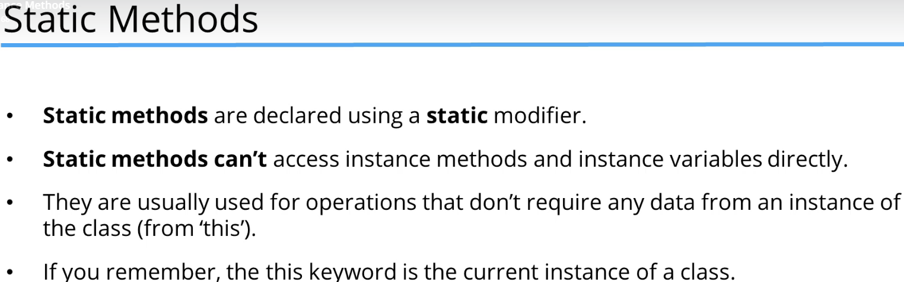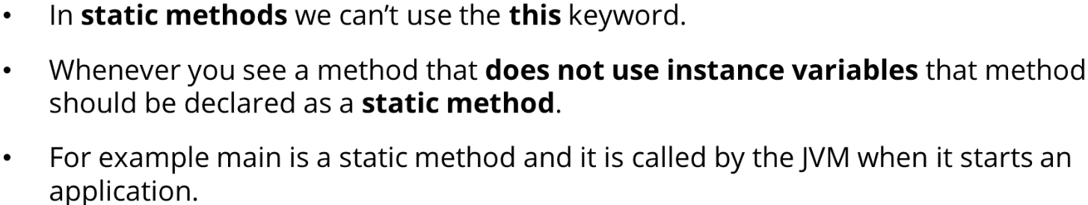

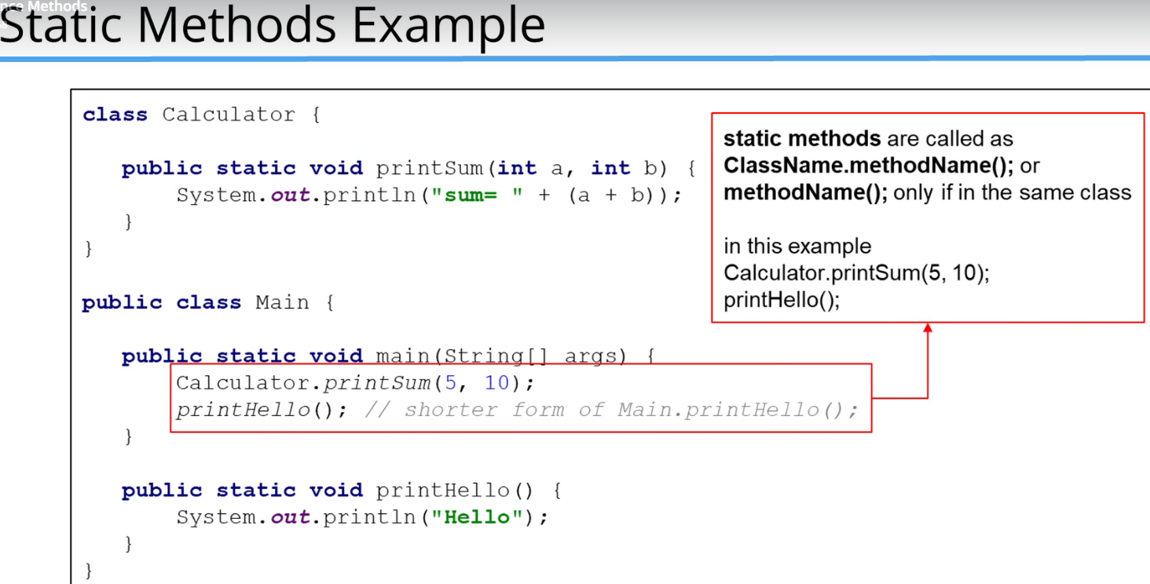  
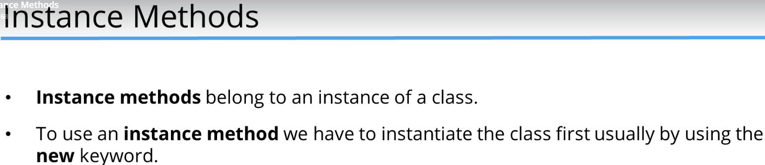  
  
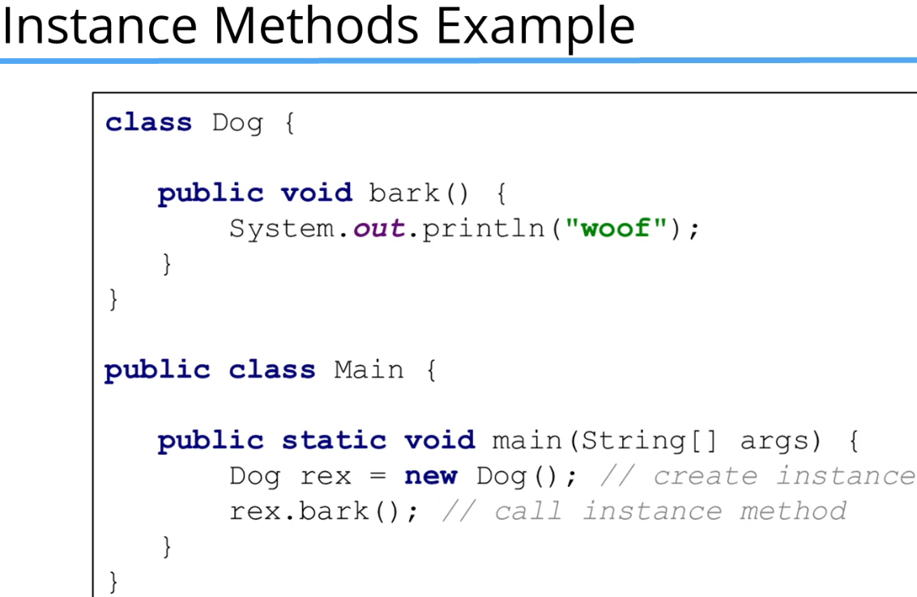  
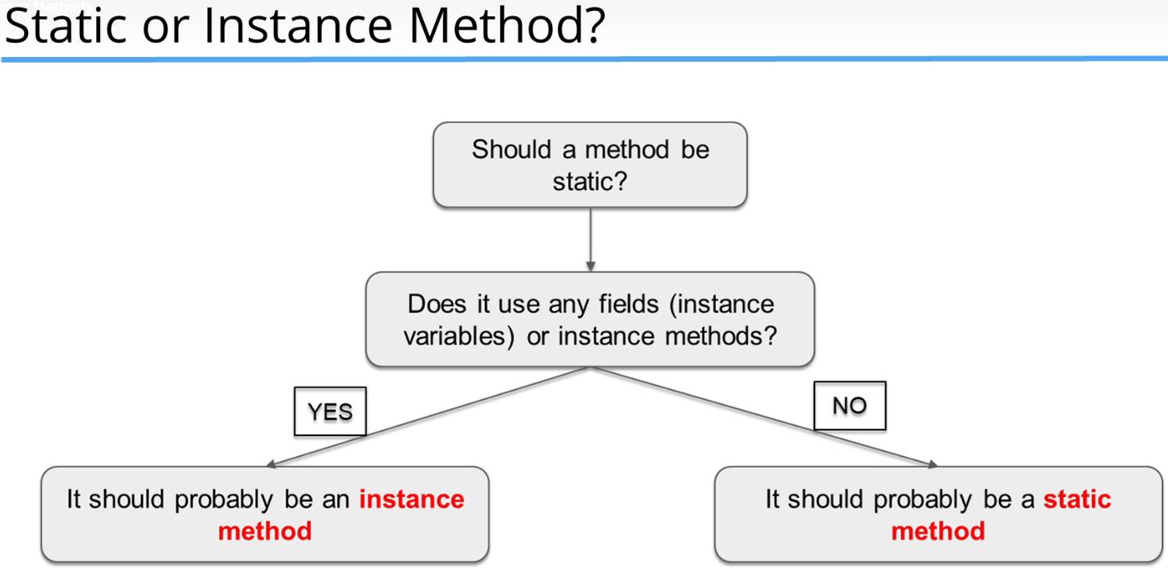

**Static vs Instance Variables**  
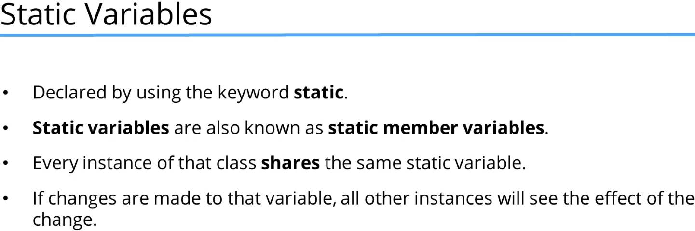  
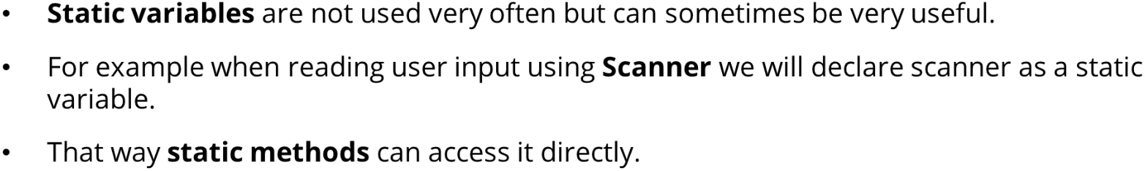  
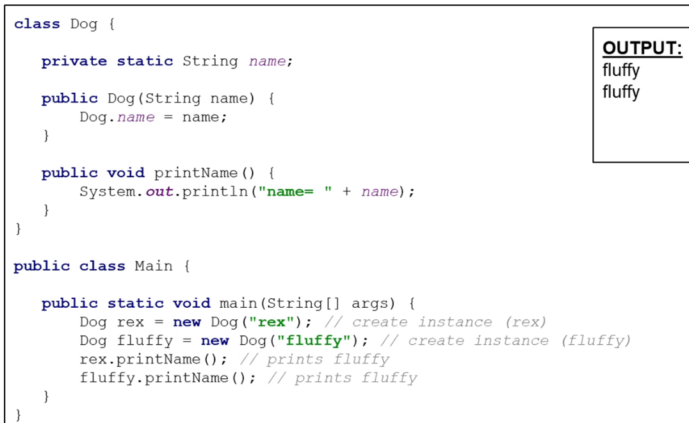  
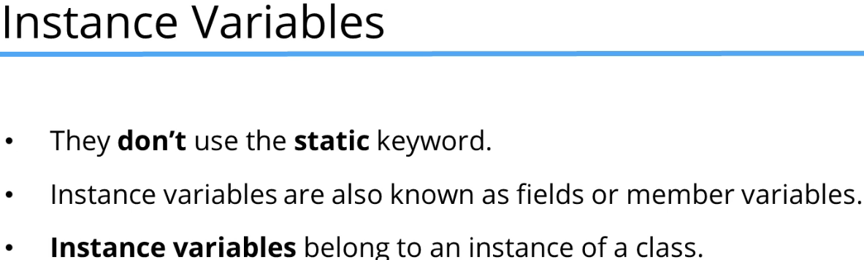  
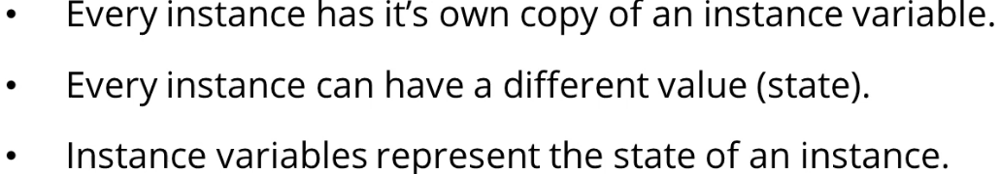  
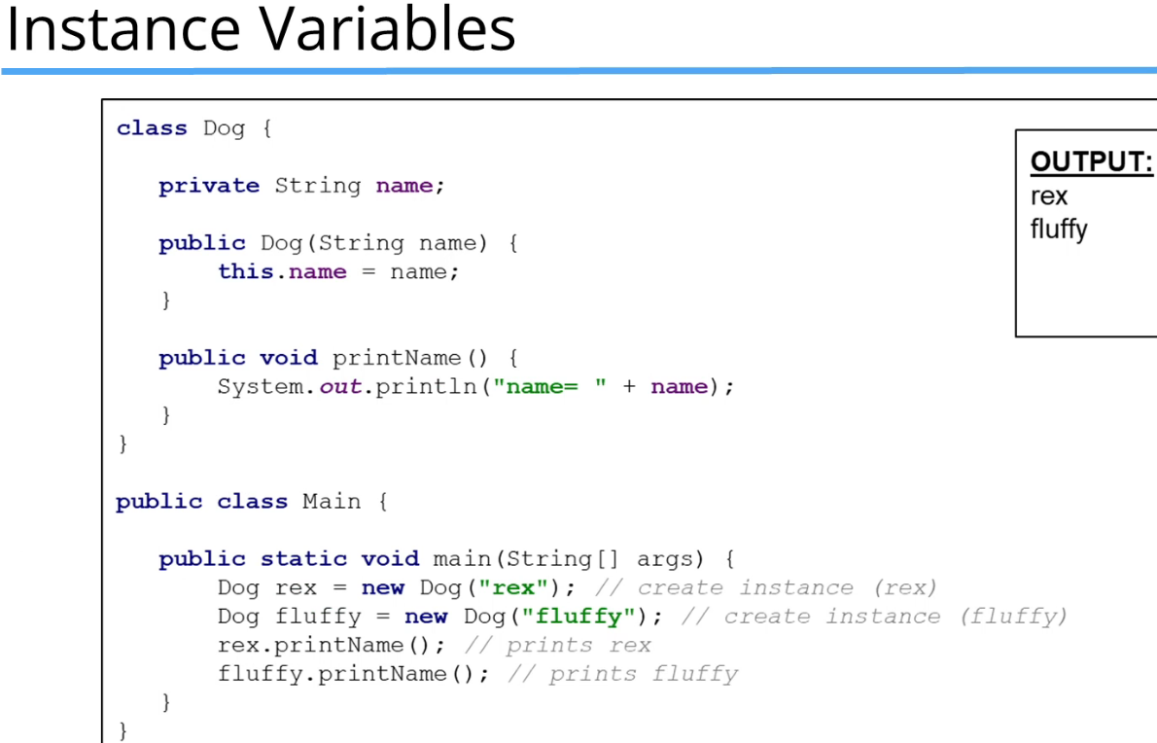

**Inheritance Challenge Part 1 (+ Challenge Exercise)**  
*Every class is automatically inheriting from a Java-supplied class called the **Object** class. You can see that by opening up your Generate command and go to Override Methods.  
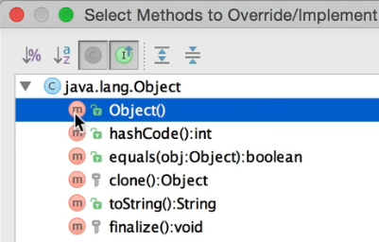  
* All those methods are inherited from java.lang.Object which is a class that classes that you create automatically extend. It’s equivalent to typing: extends Object in your class.  
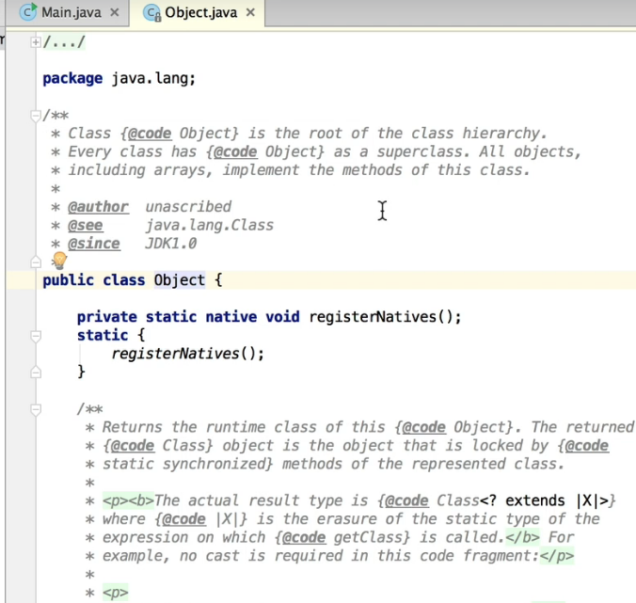  
  
  
  
  
  
  
  
  
  
  
  
  
  
  
  
  
* **Vehicle**  
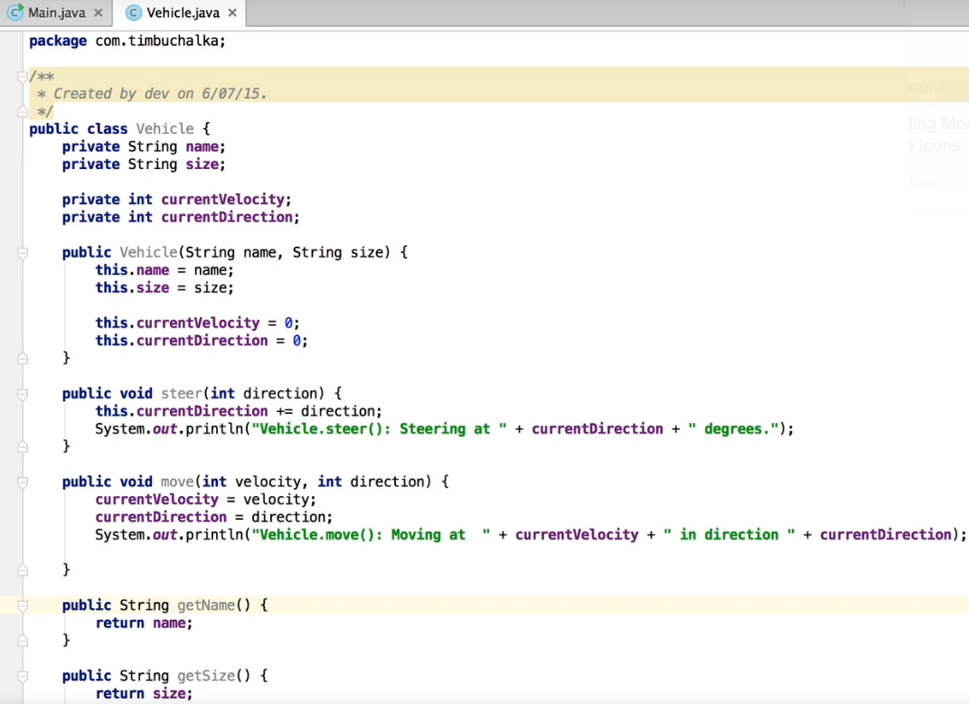  
 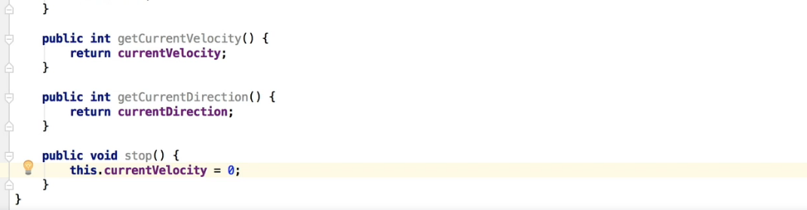  
* **Car**  
* I define the changeVelocity in the Car class too because in the future we might want to have some other things to test like the maximum speed or something like that.  
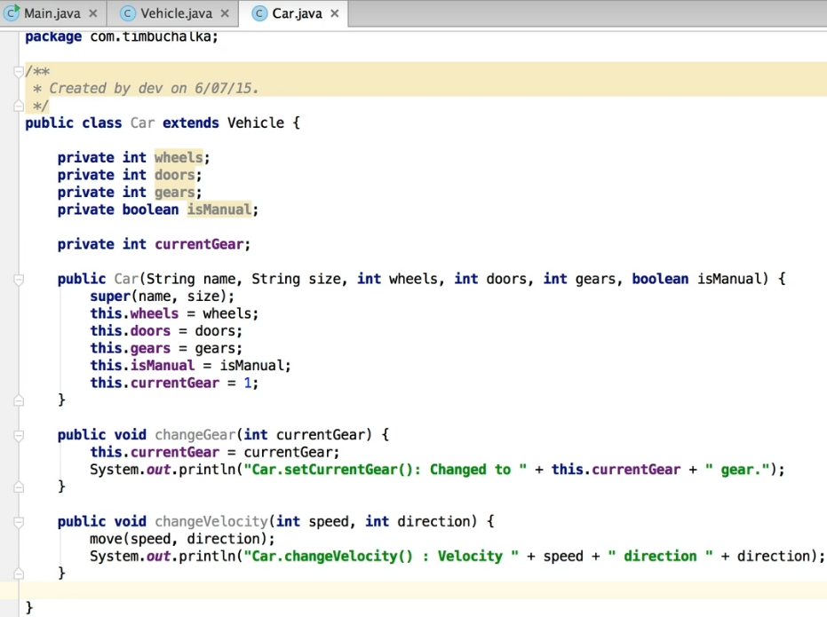  
* **Outlander**  
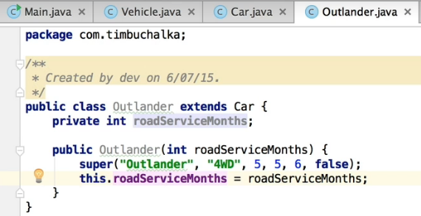  
* To keep things simple we’re going to assume there’s only 1 type of Outlander so we can actually hardcore all these values.

**Inheritance Challenge Part 2**  
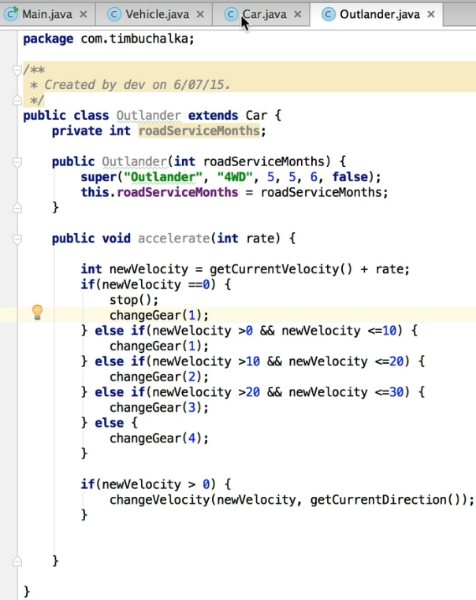  
* The rate is the difference in speed from the current speed.  
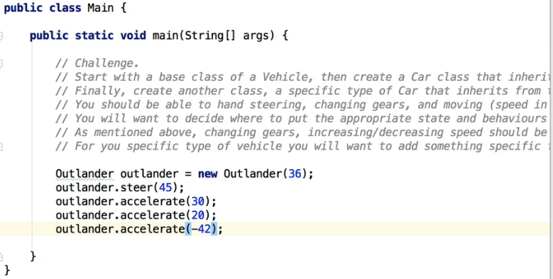  
* Now we’ve effectively implemented a method to change gears automatically based on the speed so we could’ve even created another class, or added that elsewhere, so that functionality was available for all cars that were automatic.  
* **Next video: Composition - it’s something that can be used in place or with Inheritance**.

**Coding Exercise 35: Cylinder**  
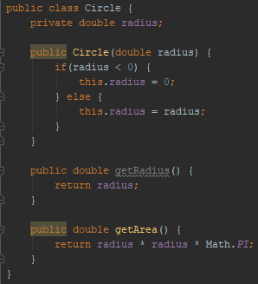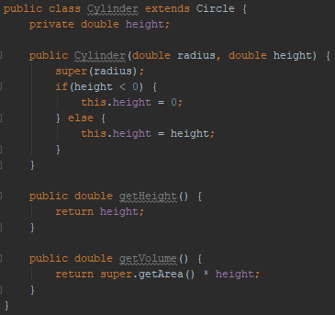

**Coding Exercise 36: Pool Area**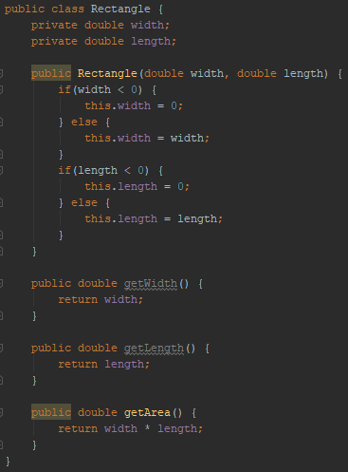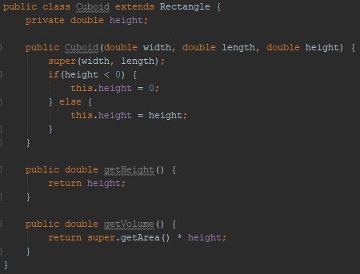

**Resources**  
x